TEST 1
PART 1: Questions 1-5
For each question, choose the correct answer
1.
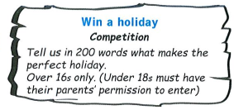  2. | - The competition is open for families with teenagers only.  B. People of all ages can participate in the competition if they wish.  C. Your parents must approve of your entering the competition if you are not eighteen.
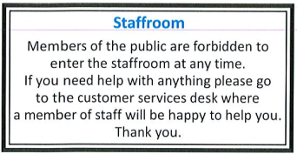  3. | A. Members of the public may only enter the staffroom if they are with a member of staff.  B. Staff should use the staffroom for dealing with customers needing some kind of help.  C. At no time may members of the public go into the staffroom.
 | A. Adrian is willing to deliver the bike to the buyer’s house if needed.  B. Anyone interested in the bike will have to pay at least 40 pounds for it.  C. The bike was originally bought for a young girl but was never actually used.
4. 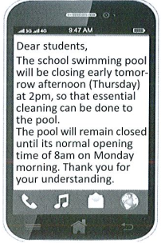 | A. The pool usually opens at 8 am in the morning.  B. The pool will be closed from Monday to Thursday next week.  C. The pool will be closed for a few hours on Thursday morning.
5. 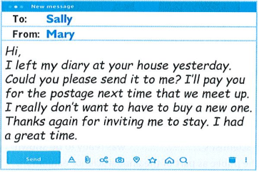 | Mary  A. is asking Sally to do her a favour and post her diary to her.  B. is disappointed as she will probably have to get a new diary.  C. forgot to pay back some money she owed to Sally

1. C
2. C
3. B
4. A
5. A

TEST 2
Part 1: Questions 1-6. For each question. Choose the correct answer.
1.  | A. Choose which size of pizza you buy still get a special price  B. Pay less at the moment for pizzas big enough to share with other people.  C. The very big pizzas at Toni’s are only available this week .
2. 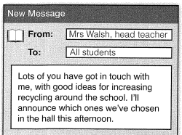 | A. Mrs Walsh wants students to contact her with plans for recycling around the school.  B. Mrs Walsh intends to let students know which of their suggestions the school will use  C. Mrs Walsh wants students to go to the hall today to help recycle rubbish
3. 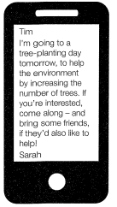 | A. Sarah is keen to get others involved in an environmental project she’s joining  B. Sarah says a tree-planting project is still short of volunteers to compete their work.  C. Sarah is wondering whether to take part in a project with he friend
4. 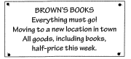 | A. This bookstore will no longer serve customers in the town after this week  B. Only books are available here this week, at a reduced price  C. To buy books from Brown’s, find their new store in town after this week
5. 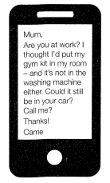 | A. Carrie is asking if her mum has washed her gym kit for her.  B. Carrie has just remembered where she left her gym kit.  C. Carrie wonders if her mum has driven to work with her gym kit.

- B
- B
- A
- C
- C

TEST 3
PART 1: (45’)
Questions 1-5
For each question, choose the correct answer
1 |  | Jenny is emailing to  A. suggest how Lara could do some sightseeing.  B. remind Lara that she needs to book some cheap train tickets.  C. invite Lara to visit some different places around the UK with her.
2 |  | A. People will be asked to discuss their favourite childhood sweets at the lecture.  B. The lecture will be about how sweet shops have changed over the last century.  C. The lecture will cover some surprising facts about sweets.
3 | 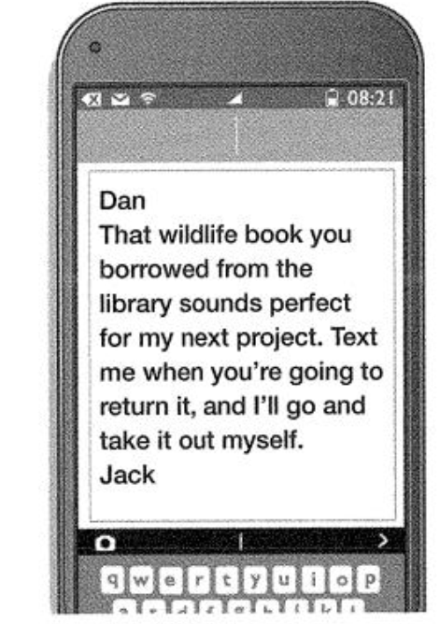 | A. Jack is asking Dan's opinion about whether a book is suitable for his project.  B. Jack wants Dan to let him know when a library book will be available.  C. Jack is recommending to Dan a useful library book he has recently borrowed.
4 | 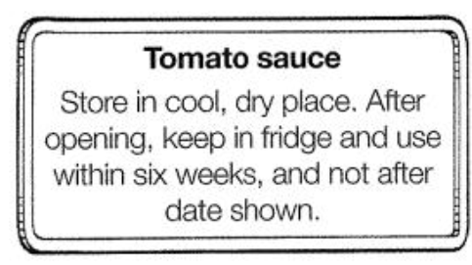 | A. Eat the sauce a maximum of six weeks after you start using it.  B. Put the sauce in your refrigerator as soon as you bring it home.  C. Make a note of the date when you bought the sauce.
5 | 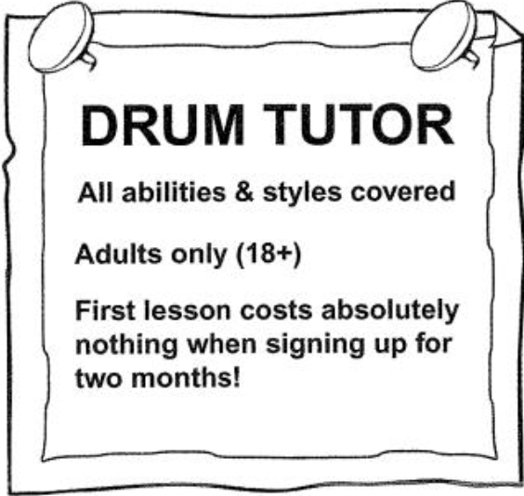 | A. The teacher is offering lessons to anyone interested in trying the drums.  B. You must intend to study for a certain period to have the free session. C. To attend these classes, students must already be at a certain level.
Part 1
- A; 2. C; 3. B; 4. A; 5. B

TEST 4
Part 1: Questions 1-6. For each question. Choose the correct answer.
1. 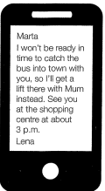 | Lena is  A. suggesting that Marta travels into town without her  B. offering Marta a lift onto town instead of catching the bus  C. checking the time she arranged to meet Marta at the shopping centre .
2. 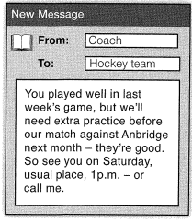 | A. The coach needs team members to tell him if they’re available for a match  B. The coach wants to help the team improve their performance before they play again.  C. The coach is congratulating the netball team for winning their game last week
3. 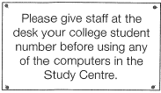 | A. Staff at the desk will show you how to use the computers here  B. These computers are reserved only for students at this college  C. If you’re not a college student, ask staff for permission to use a computer
4.  | What does Mum want to know?  A. how to find the sports shop that’s repaired Tom’s racket  B. Whether the sports shop will be open when she finishes work  C. If Tom is going to be available to pick up his racket
5.  | A. This store has more second-hand instruments available than new ones  B. You can only buy instruments here that other people have already used.  C. This store doesn’t charge a lot for instruments that aren’t new.

- A
- B
- B
- C
- C

TEST 5
Part 1: Questions 1-6. For each question. Choose the correct answer.
1. 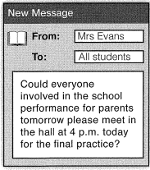 | A. Mrs Evans wants to check who is taking part in the performance this afternoon.  B. Mrs Evans wants everyone to practice their performance again before the audience sees it.  C. Mrs Evans is letting students know that parents are coming to the practice tomorrow. .
2.  | A. If you need bread during your visit, it’s available for sale inside the shop.  B. Feeding the birds on the lake is not allowed unless you have special permission  C. Visitors are encouraged not to give the birds anything apart from proper bird food.
3.  | A. Tim must decide whether he’s well enough to swim after his injury.  B. Tim’s mum doesn’t think Tim is fit and ready to go swimming yet.  C. Tim needs to inform his swimming coach that he’s injured his leg
4.  | Jade wants Lucy to  A. tell Jade if she knows where a missing item is.  B. accompany Jade on a shopping trip into town.  C. help Jade to replace something she’s lost
5. 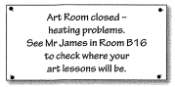 | A. Art classes will be in Room B16 as the Art Room is too cold.  B. To find out which room to go to for art lesson, ask Mr James.  C. Mr James is taking all art lessons unit problems in the Art Room are fixed.

- B
- C
- A
- C
- B

TEST 5
Part 1: Questions 1-6. For each question. Choose the correct answer.
1.  | A. Mrs Evans wants to check who is taking part in the performance this afternoon.  B. Mrs Evans wants everyone to practice their performance again before the audience sees it.  C. Mrs Evans is letting students know that parents are coming to the practice tomorrow. .
2.  | A. If you neen bread during your visit, it’s available for sale inside the shop.  B. Fe.eding the birds on the lake is not allowed unless you have special permission  C. Visitors are encouraged not to give the birds anything apart from proper bird food.
3.  | A. Tim must decide whether he’s well enough to swim after his injury.  B. Tim’s mum doesn’t think Tim is fit and ready to go swimming yet.  C. Tim needs to inform his swimming coach that he’s injured his leg
4.  | Jade wants Lucy to  A. tell Jade if she knows where a missing item is.  B. accompany Jade on a shopping trip into town.  C. help Jade to replace something she’s lost
5.  | A. Art classes will be in Room B16 as the Art Room is too cold.  B. To find out which room to go to for art lesson, ask Mr James.  C. Mr James is taking all art lessons unitl problems in the Art Room are fixed.

- B
- C
- A
- C
- B

TEST 6
PART 1: Questions 1-5
For each question, choose the correct answer
1.
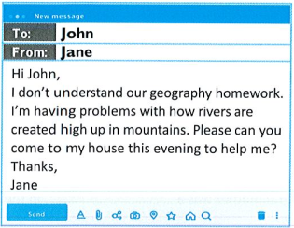  2. | What does Jane want John to do?  A. meet her at school this evening to do some homework together  B. help her understand something she can’t on her own in a school subject  C. explain how mountains are created as she has trouble understanding
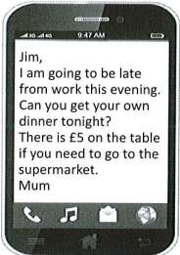  3. | A. Jim’s mum will be cooking dinner tonight later than usual.  B. Jim’s mum can’t go to the supermarket on her way back from work.  C. Jim’s mum will not be home at her normal time today.
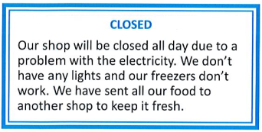 | A. The shop will remain closed for a few hours until the power is back on.  B. No food can be bought here because of a power cut.  C. One cannot shop for food at this shop as all fresh products have been sold out.
4.  | A. The owners of a missing pet are asking for help to locate him.  B. The cat was found in the local park and is waiting for its owners to collect him.  C. Those interested in volunteering to help search for Tiddles should contact his owners by phone.
5.  | A. If you want to have a party at Bob’s Burger Bar, you can decide on the birthday menu online.  B. Bob’s Burger Bar can make preparations for your birthday party including food and decorations.  C. Bob’s Burger Bar is a suitable place to celebrate a special occasion with one’s friends.

1. B
2. C
3. B
4. A
5. C

TEST 7
Part 1: Questions 1-6. For each question. Choose the correct answer.
1. 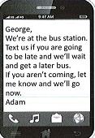 | A.George should tell Adam if he is going to be delayed  B.George should tell Adam which bus he is on  C.George should get a later bus to the station .
2.  | A. Mary will meet Sally in Rome  B. Sally got tired of walking in Rome  C. Sally has done a lot of sightseeing
3. 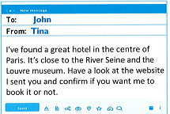 | A.John needs to see if he likes the hotel  B.John needs to book the hotel himself  C.John needs to find a hotel near a museum
4. 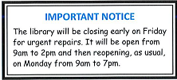 | A. The library will not open on Friday  B. The library will closed at the weekend  C. The library will close later than usual on Monday.
5.  | A. The Competition is only for children who have a pet  B. Children must paint or draw a particular subject.  C. Children can compete in both groups if they want to

- A
- C
- A
- B
- B

TEST 8
Part 1: Questions 1-6. For each question. Choose the correct answer.
1. 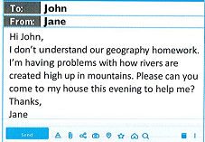 | What does Jane want John to do?  - A.Meet her at school this evening to do some homework together  - B.Help her understand something she can’t on her own in a school subject  C.Explain how mountains are created as she has trouble understanding.
2. 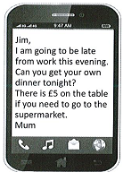 | A. Jim’s mum will be cooking dinner tonight later than usual.  B. Jim’s mum can’t go to the supermarket on her way back from work.  C. Jim’s mum will not be home at her normal time today.
3. 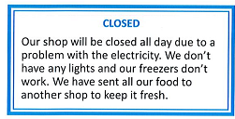 | AThe shop will remain closed for a few hours until the power is back on  B.No food can be bought here because of power cut  C.One cannot shop for food at this shop as all fresh products have been sold out.
4.  | A. The owner of a missing pet are asking for help to locate him  B. The cat was found in the local park and is waiting for its owner to collect him.  C. Those interested in volunteering to help search for Tiddles should contact his owners by phone
5.  | A. If you want to have a party at Bob’s Burger Bar, you can decide on the birthday menu online  B. Bob’s Burger Bar can make preparations for your birthday party including food and decorations  C. Bob’s Burger Bar is a suitable place to celebrate a special occasion with one’s friends

1.B
2.C
3.B
4.A
5.C

